**Chapter 4**

**HOMEWORK 1: Answer the questions for each situation.**

**1. Frankie is employed by Sherman Bros. Insurance. In 2013 his salary was $48,500. Frankie participates in the 401(k) retirement plan his employer has set up. In 2012, Frankie contributed $4,000 to the plan. Frankie also received the following from his employer in 2012:**

* **A Florida vacation worth $3,264 as a prize for meeting his sales goals. Frankie was not able to take the vacation until January 2014.**
* **$200 tickets to a pro basketball game as a Christmas present.**
* **Group health insurance premiums valued at $3,400.**
* **$2,500 as reimbursement for his travel costs. Frankie does not have to account to Sherman Bros. for the reimbursements or return any money he does not spend.**

1. **Which of the above 4 items are taxable to Frankie in 2013?**
2. **What is the amount of employee compensation that will be shown in box 1 of Frankie’s Form W-2?**

**HOMEWORK 2: Fill out page 1 of Form 1040 through line 7 and page 2, line 62, for the following using the information and forms provided.**

1. 1. Austin L. (SSN 032-78-6543, born 5/16/1979) and Felicity N. Geary (SSN 044- 65-4321, born 7/18/1981) are married and, in 2012, lived together at 14 Shady Way, Brooklyn, NY 11201. Their son Ronnie (SSN 511-33-9999, born 8/25/2000) and their daughter Darlene (SSN 511-51-1111, born 5/31/2004) are qualifying children for the child tax credit.

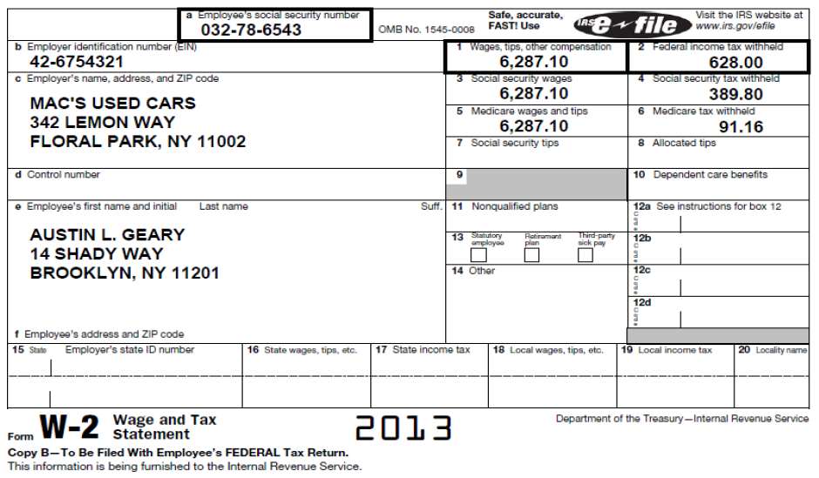

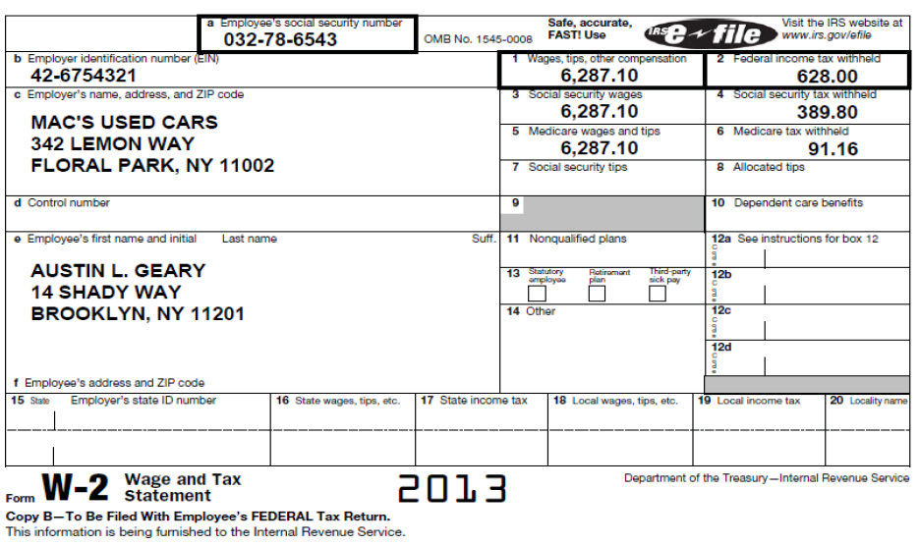

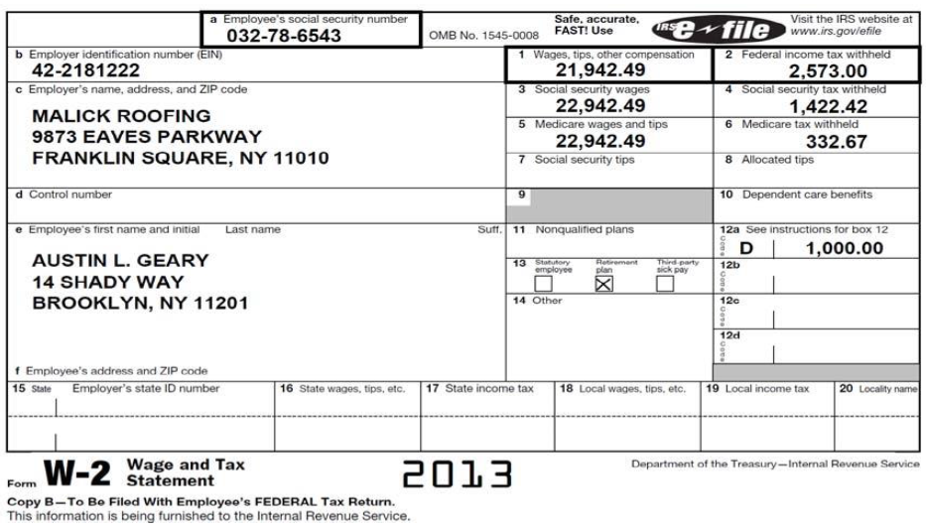

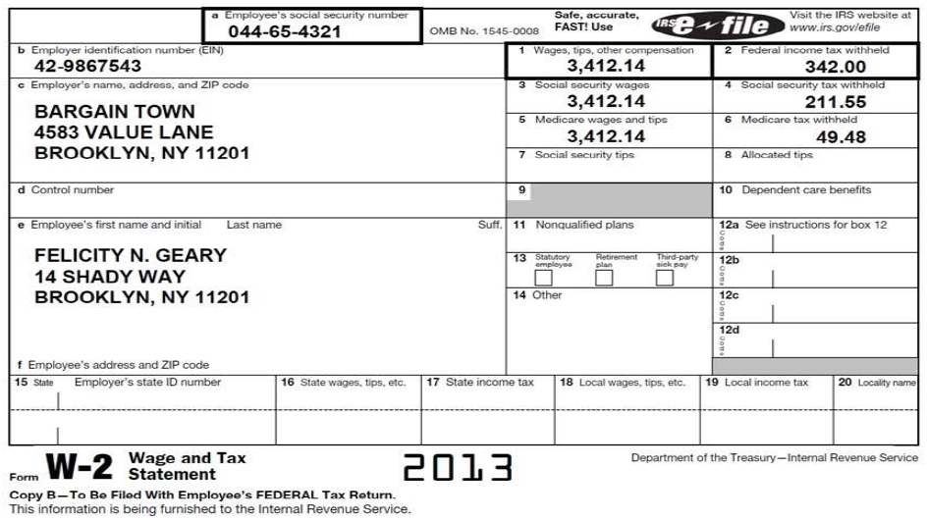

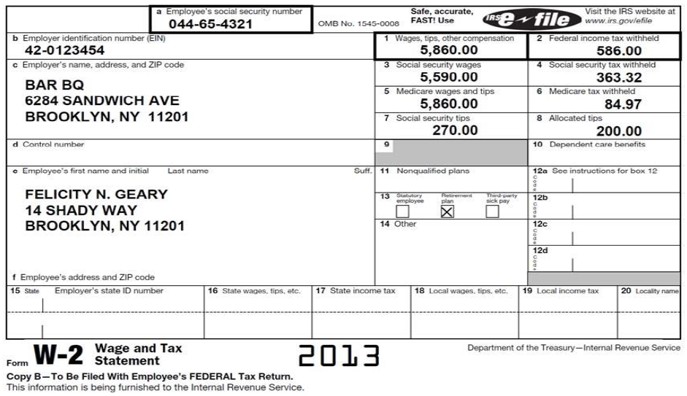

**HOMEWORK 3:** Craig R. Gregory (SSN 333-98-7654, born 9/24/1977) is divorced. He keeps up a home for himself and his son Barry (SSN 233-32-3232, born 6/7/2003), who lives with him. Craig has signed Form 8332 allowing his former wife to claim the exemption for Barry. Craig pays 70% of the total support for his widowed stepfather Lucian Alexander (SSN 277-77-8787, born 12/12/1939) who does not live with him. Lucian’s gross income in 2012 was $2,400.

On some weekends, Craig works as a waiter at a banquet hall. In January his tips were $17 and in March his tips were $19 in cash. He did not report these tips to his employer. For every other month, Craig received $20 or more in tips and reported these to his employer.

(Fill out page 1 of Form 1040 through line 7 and page 2, line 62, for the following using the information and forms provided.)

